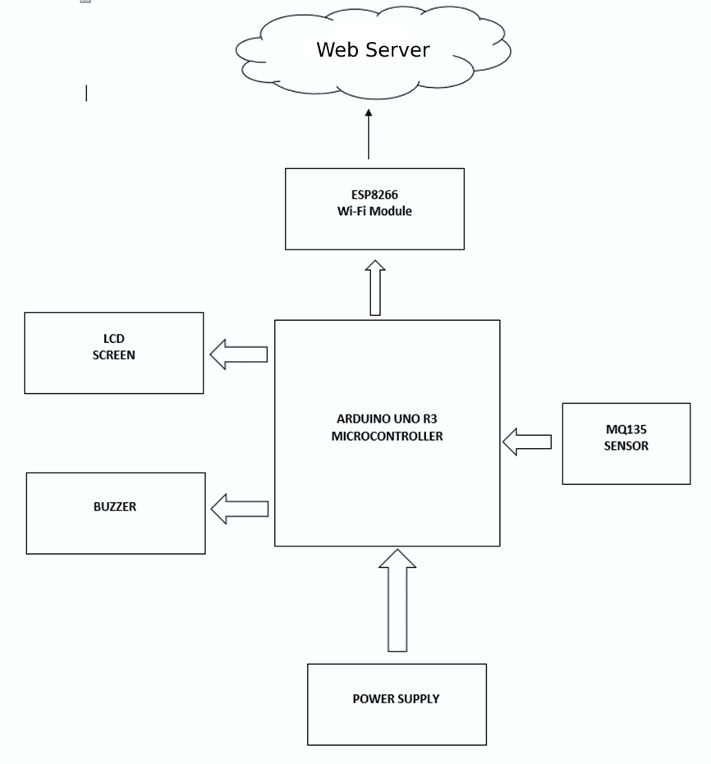

***Figure 2: Block Diagram (AQMS)***

The above block diagram provides a detailed description of the arrangement of hardware components that are placed accordingly. This ensures that the system is able to function properly and all components are able to work together seamlessly. This diagram is essential in understanding the inner workings of the system and can help troubleshoot any issues that may arise.

## Hardware Component

### Arduino Uno R3

The Arduino Uno R3 is a compact, microcontroller board equipped with the ATmega328 microcontroller. It features 14 digital input/output pins, of which 6 can be utilized as PWM outputs, and 6 analog inputs. The board has a 16 MHz ceramic resonator, a USB port for connection to a computer, a power jack for an AC-to-DC adapter or battery, an ICSP header for programming, and a reset button. To start using the Arduino Uno R3, simply connect it to a computer via USB or power it using an AC-to-DC adapter or a battery. All the components required to support the microcontroller are included in the board.

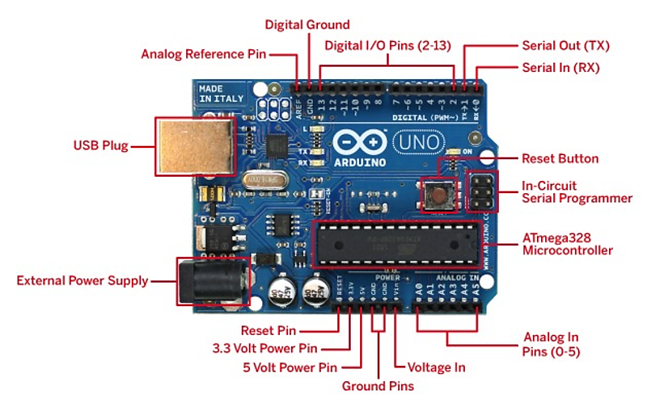

***Figure 3: Arduino Uno R3 Board***

Additionally, the Arduino Uno R3 is a versatile platform that allows for a wide range of applications, from simple DIY projects to complex industrial systems. Its open-source nature makes it accessible to hobbyists, students, and professionals alike, and its large community of users and developers provide a wealth of resources and support. Whether you're a beginner or an experienced maker, the Arduino Uno R3 is a powerful tool for bringing your ideas to life.

### MQ135 Sensor

The MQ135 sensor is a versatile tool for detecting a range of gases in the air, including ammonia, methane, carbon monoxide, and hydrogen. It consists of a sensing element, made of a material that is responsive to the gas being detected, and a resistor that adjusts its sensitivity. The MQ135 operates on metal oxide semiconductor (MOS) technology and is capable of detecting a wide range of gases, making it suitable for use in various applications such as air quality monitoring, industrial gas monitoring, and environmental gas monitoring.

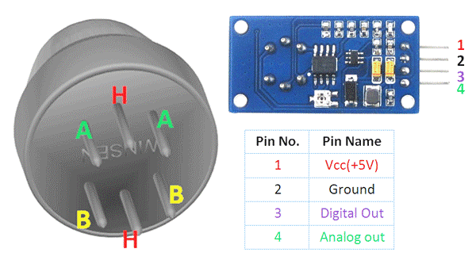

Figure 4: MQ135 gas sensor

Furthermore, the MQ135 sensor is known for its accuracy, reliability, and ease of use. It is widely used in air quality monitoring systems and provides valuable information on the quality of air in a given environment. The MQ135's ability to detect multiple gases makes it an ideal solution for a variety of applications where air quality is a concern. Whether in homes, offices, or industrial settings, the MQ135 sensor can help monitor and maintain healthy air quality levels.

### DHT11 Sensor

The DHT11 sensor is a low-cost, digital temperature and humidity sensor that is widely used in a variety of applications. It measures both temperature and humidity and outputs the data as a digital signal that can be easily read by a microcontroller or other digital device. The DHT11 sensor is equipped with a temperature-sensitive element and a humidity-sensitive element, both of which are housed in a compact, weatherproof package. The DHT11 sensor is known for its high accuracy and stability, making it a reliable choice for monitoring environmental conditions. Its compact size, low power consumption, and ease of use make it an ideal solution for projects that require temperature and humidity data, such as weather stations, HVAC systems, and indoor air quality monitoring.

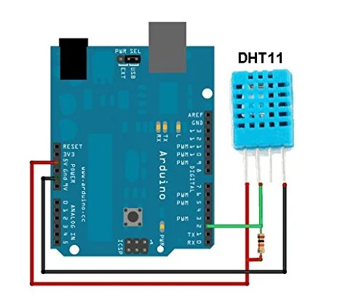

***Figure 5: DHT11 Temperature and Humidity Sensor***

Whether you're a hobbyist, student, or professional, the DHT11 sensor is a valuable tool for monitoring temperature and humidity levels in a variety of applications. Its affordability, reliability, and accuracy make it a popular choice for projects of all sizes and complexities.

### ESP8266

The NodeMCU is a compact, low-cost, and powerful development board that is widely used for IoT projects. It is based on the ESP8266 chip, which provides built-in Wi-Fi capabilities and a microcontroller for executing custom code. The NodeMCU has a variety of digital and analog input/output pins, as well as an on-board flash memory for storing code and data. As a seasoned American engineer, I would highly recommend the NodeMCU for final year projects in the field of IoT. Its versatility and ease of use make it an ideal platform for a wide range of projects, from simple IoT devices to complex smart home systems. The NodeMCU's Wi-Fi capabilities allow for easy and secure communication with other devices and cloud platforms, making it a valuable tool for data collection, analysis, and visualization.

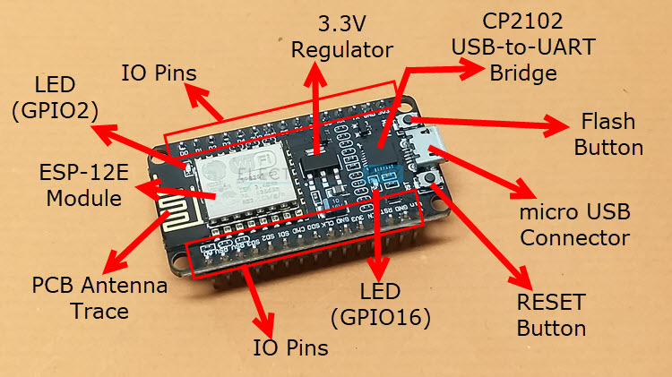

Figure 7: ESP8266

Furthermore, the NodeMCU's open-source nature and large community of users and developers make it a great choice for students and hobbyists who are looking to explore the world of IoT. With its compact size, low power consumption, and affordability, the NodeMCU is an excellent solution for projects of all sizes and complexities. Whether you're just starting out in the field of IoT or looking for a reliable platform for your final year project, the NodeMCU is a valuable tool for bringing your ideas to life.

### Resistor

Resistors are passive electronic components that are used to limit the flow of current in a circuit. They are essential components in a wide range of electrical and electronic systems, and they come in a variety of shapes, sizes, and resistance values to meet the needs of different applications. In simple terms, resistors reduce the flow of electricity in a circuit, which allows engineers to control the voltage and current levels in their systems. This helps to prevent damage to components and to ensure that the system operates within safe and acceptable limits.

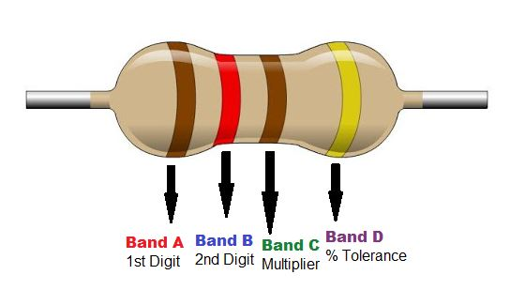

***Figure 8: Resistor***

When selecting a resistor for a project, engineers must consider factors such as the resistance value, tolerance, power rating, and physical size. These factors are important to ensure that the resistor meets the requirements of the system and performs as expected. Resistors are an essential component in electronic systems, and they play a critical role in controlling the flow of electricity in a circuit. Whether you're designing a simple LED lighting system or a complex industrial control system, resistors are an essential tool that every engineer should have in their toolkit.

### Jump Wires

Jumper wires play a crucial role in ensuring the proper functioning of an Arduino project. They serve as the connective tissue of a circuit, linking various components and allowing them to communicate and work together. Without jumper wires, circuits would simply not be able to function, making them an essential part of any project.

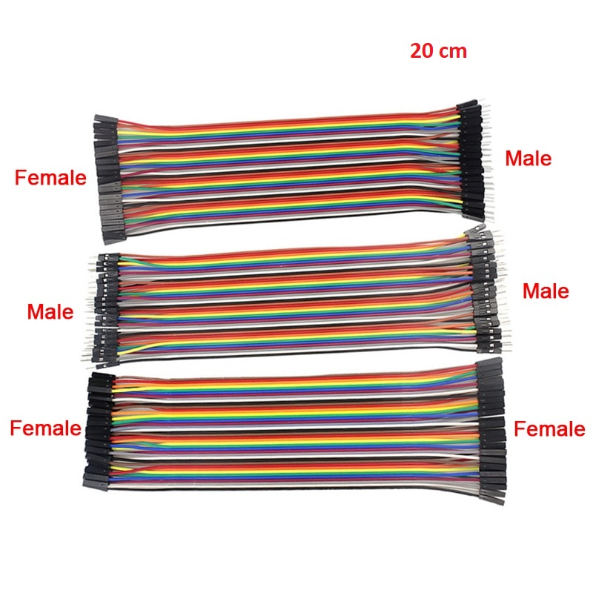

Figure 9: Jumper wires

It is important to choose the right type and size of jumper wires for your project, as the wrong ones can negatively impact the circuit's performance. Different projects have different requirements and can benefit from different types of jumper wires, such as female-to-male, male-to-male, or female-to-female, among others. The size of the jumper wires also matters, as thicker wires can handle more current, while smaller wires are more suitable for more delicate circuits. In short, jumper wires are a critical component in any Arduino project, and it is important to choose the right ones to ensure that your circuit functions properly. Whether you're working on a simple hobby project or a complex industrial system, jumper wires play an essential role in connecting the components of your circuit and making your project a success.

### Breadboard

A breadboard is a versatile and convenient tool for prototyping electronic circuits. It provides a base for building and testing electronic circuits without the need for soldering. The breadboard consists of a grid of intersecting metal clips that allow components to be easily connected, making it an ideal platform for experimenting with different circuit configurations.

`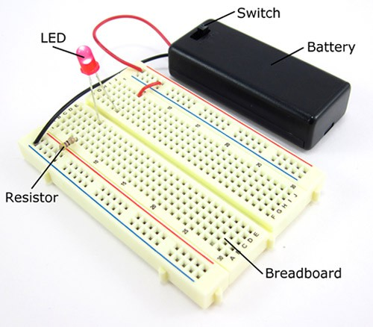

Figure 10: Breadboard

This prototyping tool is ideal for hobbyists, students, and engineers, who want to quickly and easily test their circuits without the hassle of soldering. The breadboard is a reusable and portable platform, making it an ideal choice for on-the-go projects, field tests, and classroom demonstrations. Whether you're testing an LED blink circuit or building a complex microcontroller project, a breadboard provides a quick and easy way to prototype and experiment with different circuit configurations. So, whether you're a beginner or an experienced engineer, a breadboard is a must-have tool for anyone who wants to bring their electronic ideas to life.

1. **LCD 16 × 2 display**

An LCD module is a widely used component that serves the purpose of displaying information on a screen. It is found in various electronic devices such as televisions, computers, and mobile phones, providing users with an efficient way to access information.

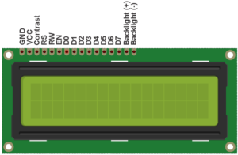

Figure 11: LCD display module

## Abstract Architecture

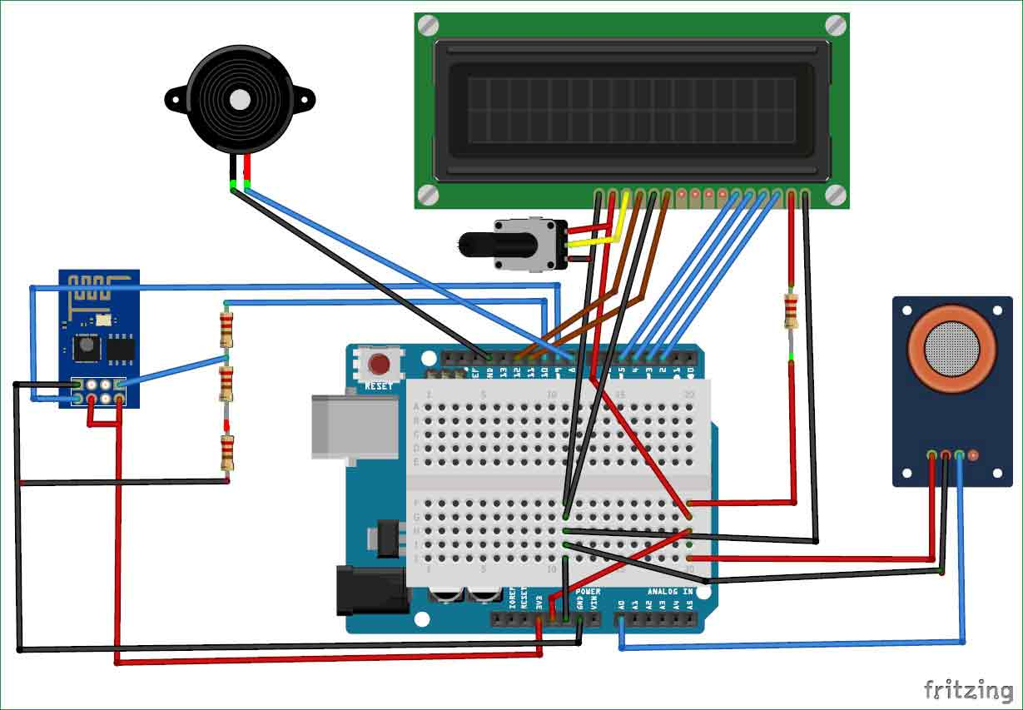

***Figure 12: Pictorial Circuit Diagram***

### Context Diagram

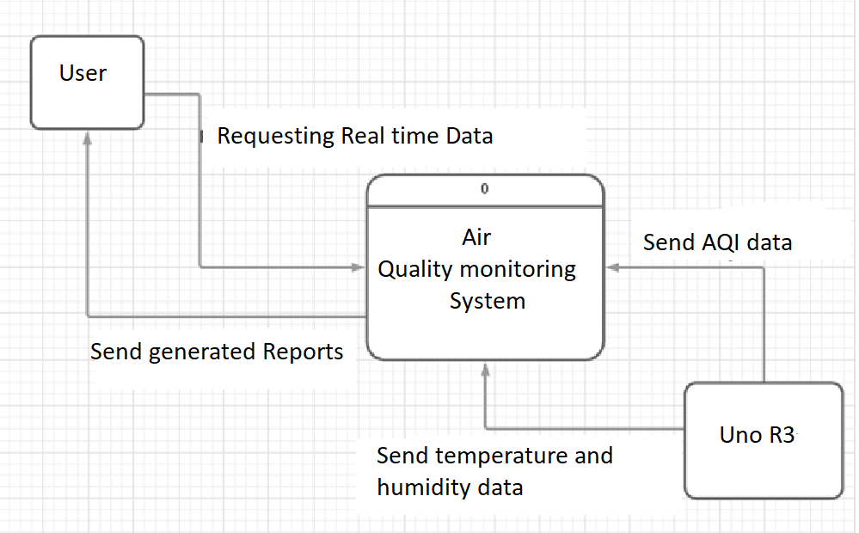

***Figure 13: Context Diagram***

A Level 0 context diagram is a high-level view of a system that shows the system's boundaries and the major components that interact with it. It is used to provide an overview of a system and to help identify the system's major stakeholders. The user requests real-time data from the Arduino by sending a request through the context diagram of the project. The Arduino then retrieves temperature and moisture data with addition to AQI data from the system and sends it back to the user. This allows the user to have up-to-date information on the conditions of the gases, moisture and temperature, which is essential for maintain good AQI.

### Data Flow Diagram

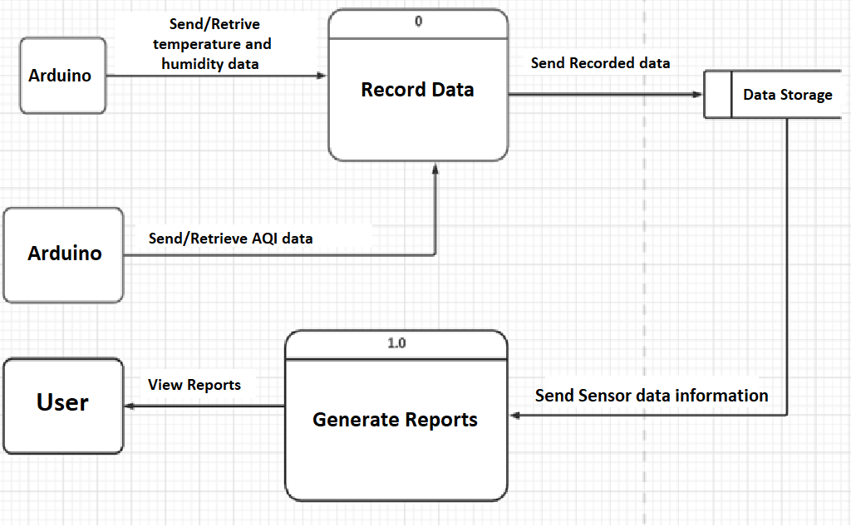

### 1.2.3 Activity Diagram

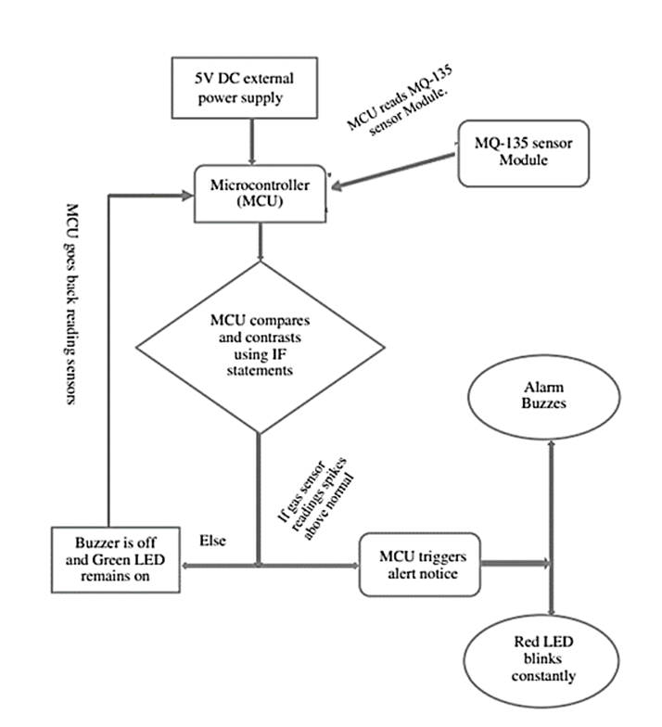

***Figure 15: Activity Diagram***

## Images:

